BITS Pilani, Dubai Campus

Dubai International Academic City, Dubai

I Semester 2020-21

CS F222 Discrete Structures for Computer Science

Assignment - I

ID No: 2019A7PS0020U

Name: Dhruv Maheshwari

Section No: 2

Ques No: 21

Ques Statement: Given a graph and a positive integer n, write a program to determine whether the graph has a cycle of length n.

Output file:

Ques 1:

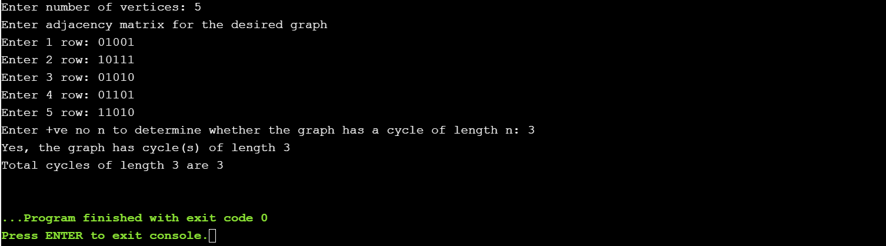

Ques 2:

